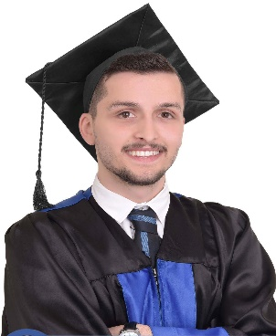 | Vildan ASLLANI  +383 45 289 099  vildanasllani@gmail.com  60000 Gjilan, Republic of Kosovo  Date of birth: 06.12.1995 | Nationality: Albanian
WORK EXPERIENCE
 | Currently seeking for work to better myself and grow professionally.
PROFILE
 | An ambitious, enthusiastic and committed Computer Science graduate who possesses a genuine interest and understanding of technology. Currently seeking a challenging work placement opportunity within a dynamic Tech firm which will offer early responsibilities, and the opportunity to develop practical computer skills.
EDUCATION
1 Oct 2017 – (in progress)  Gjilan, kosovo | Master of Computer Sciences E- Government  University of "Kadri Zeka" Republic of Kosovo  e-Government
1 Sep 2014 – 10 Jun 2017  Gjilan, kosovo | Bachelor of Computer Science  University of ‘Kadri Zeka’ Gjilan, Republic of Kosovo  SOFTWARE ENGINEER AND WEB DESIGN
1 Sep 2011 – 14 May 2014  Gjilan, kosovo | High School  Gymnasium ‘Zenel Hajdini’
1 Sep 2002 – 13 Jun 2011  Gjilan, kosovo | Primary School  School ‘Abdullah Tahiri’
General skills

Communicates effectively and professionally
Driven by personal and collective team success
Strong integrity and moral values
Sociable with great personality
Computer skills |  | Language | Hobbies
Microsoft Office Package  OOP Programing  C#, C++  Php(Laravel Framework)  HTML(5),Javascript,CSS3,SCSS  (CSS Framework integration)  Relational databases(MySQL, SQL) |  | Albanian (native)  English (fluent)  Spanish | Sports  Music  Technology

